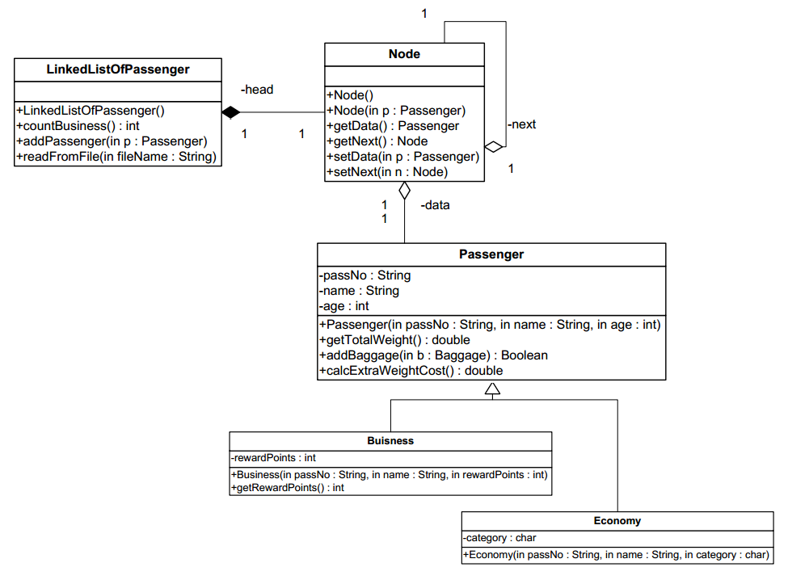**Question 1:**

**LinkedlistOfPassenger** class:

**o Methods:**

* **LinkedlistOfPassenger():** constructor.
* **countBusiness():** this method returns the number of business passengers in the list.
* **addpassenger(p: Passenger):** this method inserts the passenger p in the correct position based on the **passNo** (note:the passengers are sorted in an ascending order)
* **readFromFile(filename: String):** this method reads all passenger objects stored in the file named filename and adds them to the list.

**QUESTION:** Translate into Java code the class **LinkedListOfPassenger.**